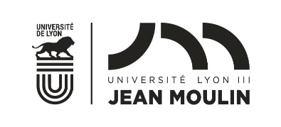
2023-2024 CALENDAR | FALL SEMESTER

DEUF AND SELF PROGRAMS
 | FACULTY  OR  SCHOOL | ARRIVAL AT LYON 3 | INTENSIVE INTEGRATION COURSE | INFORMATION DAY  Compulsory except for DEUF students who attend the integration course | CHOICE OF COURSES  (Tutor guidance available) | FIRST DAY OF REGULAR COURSES | EXAMS
DEUF PROGRAM  = Courses in French | Law School  (Faculté de Droit) | August 22 to 29 | August 28 to September 1er | August 30  at 9:00 am | August 30 to September 11 | Undergraduates:  September 4 (lectures) | Undergraduates:  4 December to January 5
 |  |  |  |  |  | Masters:  September 11 | Masters:  December 11 to January 6
 | iaelyon School of Management  (iaelyon) |  |  |  |  | Undergraduates:  September 4 (lectures)  September 18 (tutorials undergraduate)  Masters:  September 4 | Undergraduates  and Masters:  11 to 22 December
 | Faculty of Philosophy  (Faculté de Philosophie) |  |  |  |  | Undergraduates and Masters:  September 4 (lectures)  September 14 (tutorials) | Undergraduates  and Masters:  11 to 23 December
 | Faculty of Languages  (Faculté des Langues  LEA and LLCER) | August 23 to 30 |  | August 31  at 9:00 am | August 31 to September 22 | Undergraduates:  September 4 LEA (Lectures)  September 11 LLCER (Lectures)  September 18 LEA and LLCER (tutorials)  Masters:  September 4 | Undergraduates and Masters:  11 December to 12 January
 | Faculty of Literature and Civilizations  (Faculté des Lettres et Civilisations) |  |  |  |  | Undergraduates and Masters:  September 6 (lectures) | Undergraduates and Masters:  27 November to 16 December
SELF PROGRAM =  Courses in English |  | August 28, 29 or 30 | August 31  to September 8 included  compulsary | August 31  at 10 am | Mid June: Email from selfprogram@univ-lyon3.fr will be sent out to SELF students | September 11 | 27 November to 8 December included
Holidays
MID-TERM BREAK |October 29 to November 5 for all faculties except Master1 Law and Master School of Management
Christmas | December 24 to January 3 for all faculties

